# Step 1: Download the code

Download the 1.0.1 release and un-tar it.

1

2

> tar -xzf kafka_2.11-1.0.1.tgz

> cd kafka_2.11-1.0.1

# Step 2: Start the ZooKeeper server

C:\apache\kafka_2.11-1.0.1\bin\windows>kafka-server-start ..\..\config\server.properties

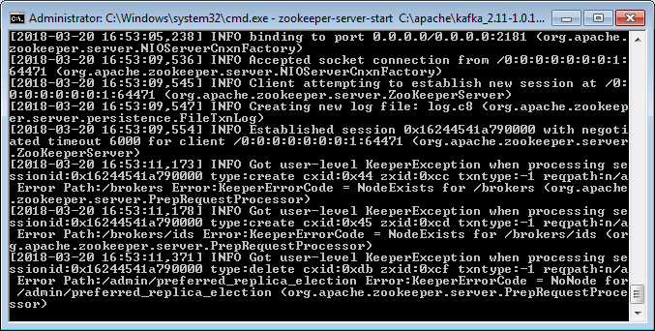

## Start the Kafka server:

C:\apache\kafka_2.11-1.0.1\bin\windows>zookeeper-server-start C:\apache\kafka_2.11-1.0.1\config\zookeeper.properties

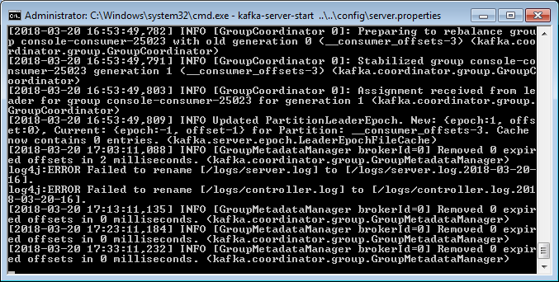

# Step 3: Create a topic

C:\apache\kafka_2.11-1.0.1\bin\windows>kafka-topics --create --zookeeper localhost:2181 --replication-factor 1 --partitions 1 --topic test

**N.B. Topic name Should be test, or else need to modify in “/netty-http-kafka/src/main/resource/config.properties”**

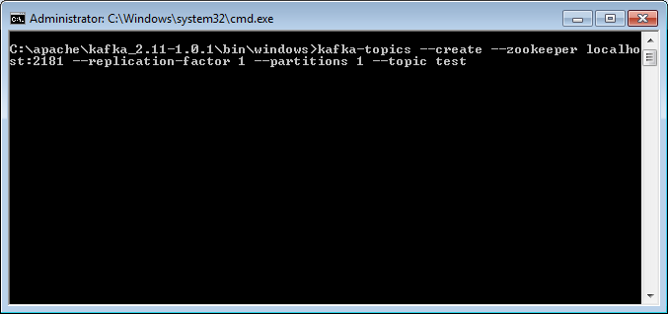

We can now see that topic if we run the list topic command:

C:\apache\kafka_2.11-1.0.1\bin\windows>kafka-topics --list --zookeeper localhost:2181

# Step 4: Send some messages through comand prompt (Optional)

C:\apache\kafka_2.11-1.0.1\bin\windows>kafka-console-producer --broker-list localhost:9092 --topic test

This is a message

This is another message

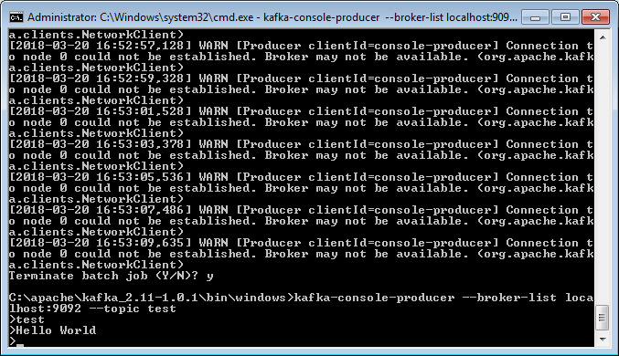

# Step 5: Start a consumer to verify message send

C:\apache\kafka_2.11-1.0.1\bin\windows>kafka-console-consumer --bootstrap-server localhost:9092 --topic test --from-beginning

This is a message

This is another message

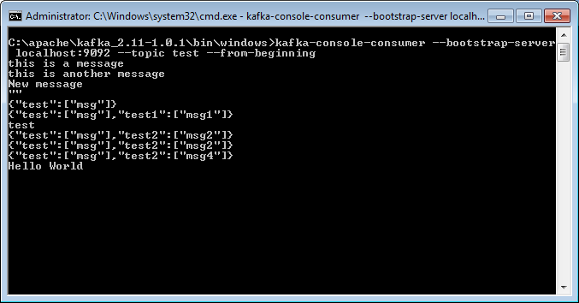

# Reference: <https://kafka.apache.org/quickstart>